Walking in Dorset
October 2019

Off we went to Dorset and after lunch at the Blue Vinny in Puddletown, we arrived at Maiden Castle, the first hill fort of the early Iron age (800-400 BC) and its banks and ditches still standing proudly over the surrounding countryside as well as the rather more recently constructed Poundbury, one of Prince Charles’s projects, visible on the west side of Dorchester

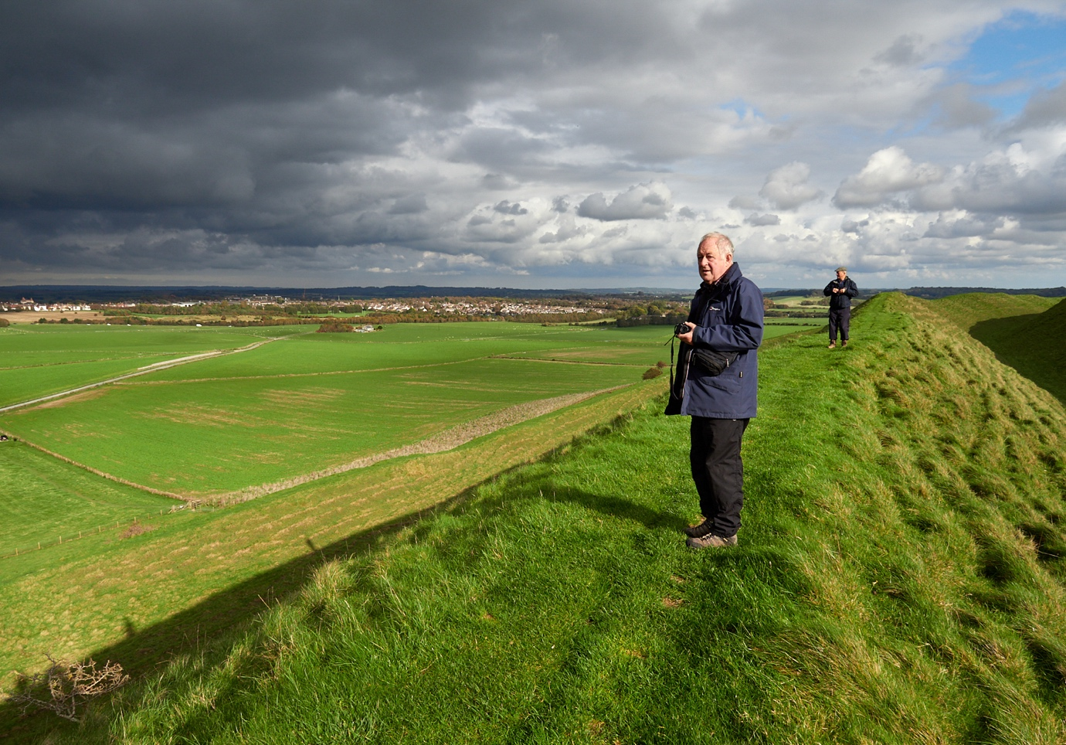

From there to West Knighton, our beds for three days. The pub is the New Inn and on this first evening is very quiet, though it becomes livelier as the week progresses.

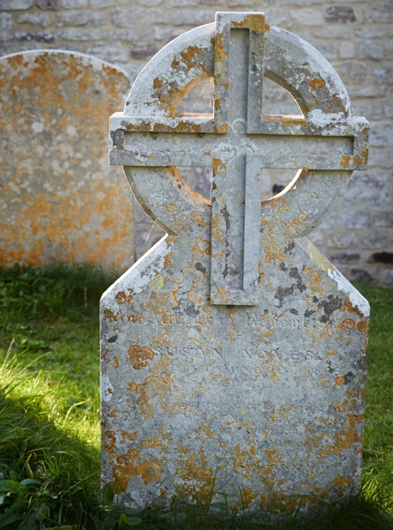

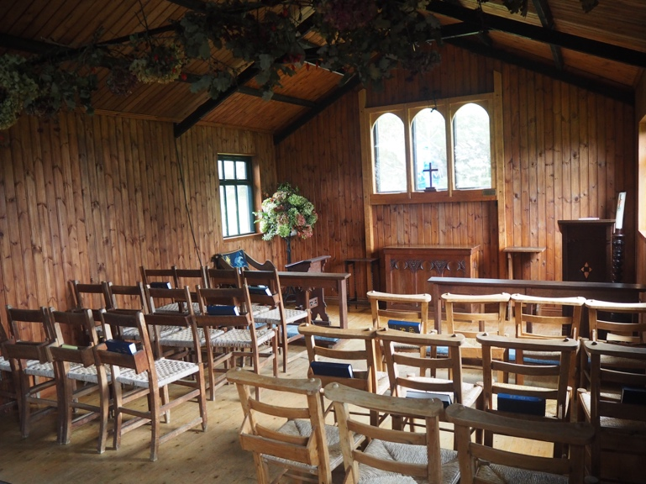
Next day we leave the car at Osmington Mills and head off to walk a short section of the south west coast path, heading east for a couple of miles through Ringstead, before returning to Osmington Mills on an inland route.
We stop at a delightful little chapel, St Catherine’s, built in 1926 by the widow of a controversial vicar who used the nearby Holworth House as a holiday home. .

Lunch is at The Smugglers Inn, Osmington Mills

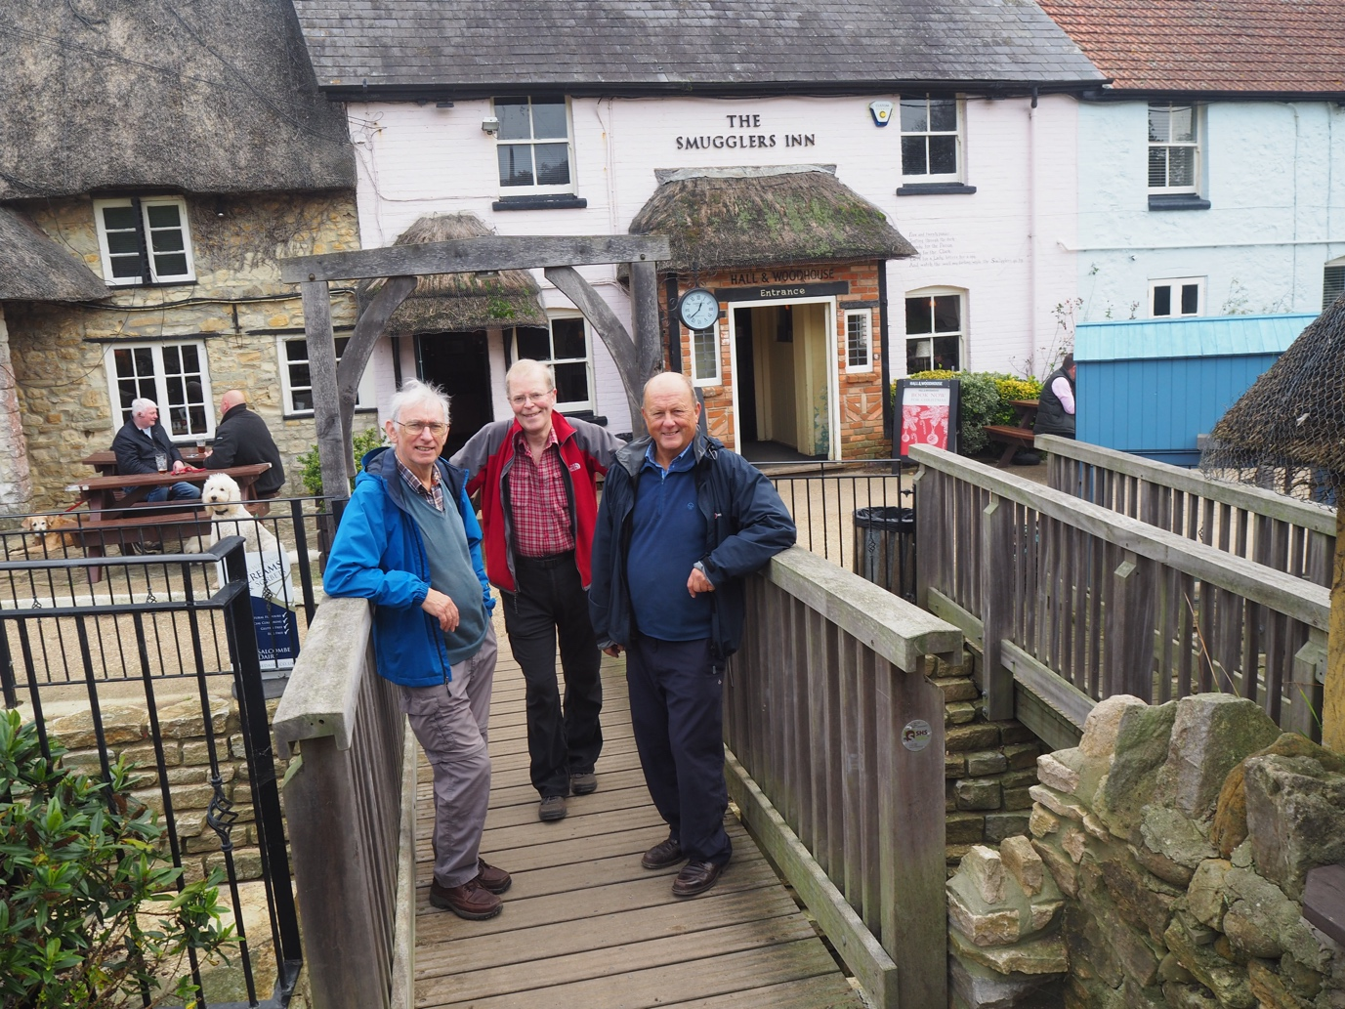

With the weather still gloomy we make a pilgrimage to Thomas Hardy’s Cottage (where he was born, made of cob and thatch and which is delightfully nestling in gardens and countryside.) Also interesting, if less appealing, was our next stop, at Hardy’s later home, Max Gate, a grand yet rather stuffy Victorian house designed by Hardy himself. Both are National Trust.

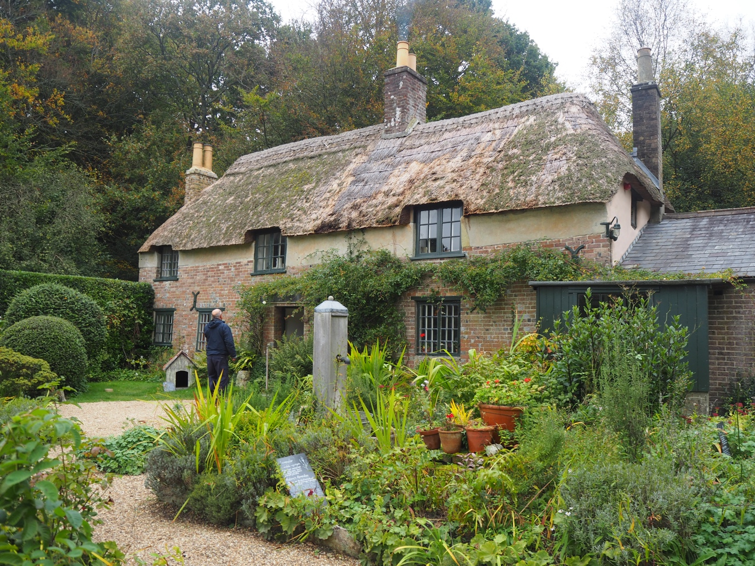

In the evening to The Wise Man, West Stafford.

On Thursday a coastal walk beckons on the Isle of Portland. This is where Portland stone comes from and there are the remains of disused quarries and stone cranes along the shore. We attempt a walk starting at the north end of the island, heading towards the cliffs on the east side. Unfortunately, the weather deteriorates with heavy rain and mist obscuring the views over the sea and Chesil Beach. We decide to head back and seek the shelter of the Cove House Inn in Chiswell. The rain stops and the weather brightens up after lunch, so we head down to Portland Bill and do a circular walk heading up the east coast past the old cranes that were used to load stone onto boats. We cut across the island and head back to Portland Bill down the west side.
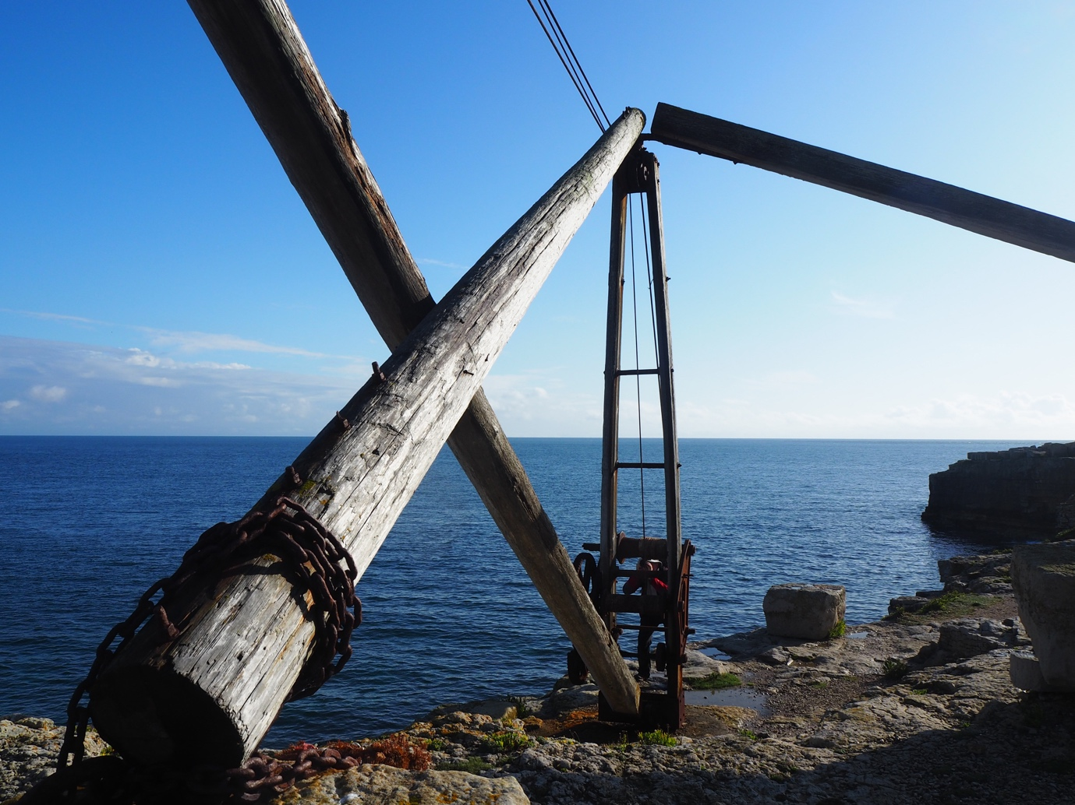

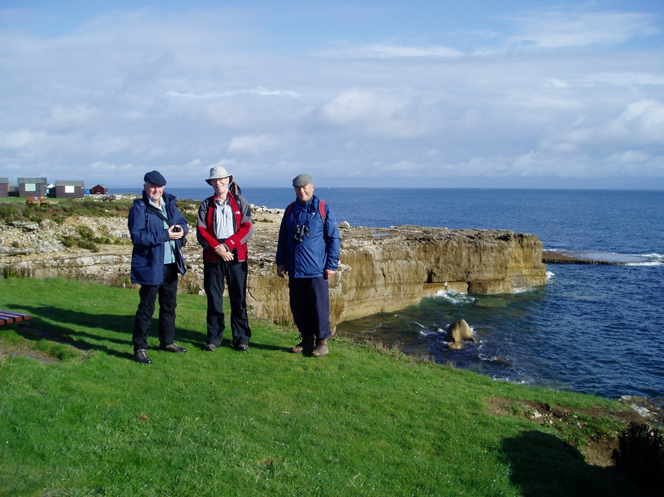
Thursday evening, we visit the quirky and cramped Blue Raddle in Dorchester. Very atmospheric and seems as if it hasn’t changed since Queen Victoria was on the throne.
Friday’s walk was to be between Childe Okeford and Stourpaine, ending at the White Horse in Stourpaine but we opted to visit the National Trust’s Kingston Lacy instead.

