Shelford Station to Babraham and back, taking in Wandlebury and Stapleford.
9¹/₂ miles, 5 hours walking. OS Explorer 209.
Trains run regularly to Cambridge (5 minutes) or stations on the Liverpool Street line to London.

Starting from Shelford Station (TL465523) head away from the village north up Hinton Way and turn right along Mingle Lane.
Just after Stapleford Church bear left along Gog Magog Way and follow the road around the left of the recreation ground to Haverhill Road.
Cross the road and walk up the hill, with open fields on your right (beyond which lies your lunch).
Continue up the hill on the footpath to Gog Magog Down.
At the gate signposted Wandlebury go in and bear right all the way, anticlockwise around the perimeter of the Down, through light woodland until you emerge on the Down itself. There are benches with excellent views over Cambridge and much of south Cambridgeshire so make the most of it in this generally flat county. The most strenuous part of your walk is over!
Admire the views, skylarks and wildflowers in season before setting off again. Follow the eastern perimeter with the fence to your right until you reach a gatre. There are views ahead towards Abingdon, but turn left along a straight path between the trees.
At the end, turn right, parallel to the Babraham Road, take the gate on your left after 100 yards and very carefully cross the busy road to Wandlebury.
Follow the main path through Wandlebury, site of an iron age fort. You could take a very short detour to the left to see the grave of the Godolphin Arabian racehorse and the Tadlow Granary.
Following the main path, now signed Roman Road as it leads through the reserve. There are useful explanatory information boards in places such as Clarke’s Corner.
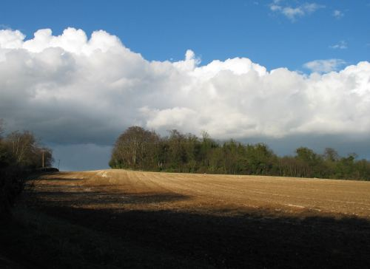
At the lodge take left turn along the straight avenue signposted Roam Road. This broad walk is a pleasure to walk along, with snow drops in January and February, Daffodils in March and blue bells in April and May.
At the T junction (TL505537) pause to get your bearings. You are outside the Wandlebury reserve and on a traffic-free Roman Road, the Via Devana. To the left over the hill are Beech Woods and to the right the Roman Road heads south-east and is also named the Harcamlow Way.
We head right towards rising ground. On our left appears a track to Fulbourn and on our right, on the far side of the tumulus Copley Hill, we take the track called Mile Road leading to the Babraham Road and signed Roman Road Walks.
At the busy Babraham Road turn right after 100 yards cross the road and take the path marked with a public footpath sign and at right angles to the road.
The path follows the field boundary and hedge until we reach a bridge over a stream on our right. This may be a restful place to pause, though in season it is heavily nettled and the bank is quite steep. It is the River Granta, which meanders through Shelford to Cambridge.
Over the bridge we see a sign indicating Roman Road Circular Walk.
Bear left through the new plantings. At the concrete gate posts turn right to follow the track as it breaks out of the planting and along the side of the field.
Near the far edge of the field is a sign pointing whence you’ve come, marked to Stapleford. Continue in the direction of Babraham along another grassy track between new planting.
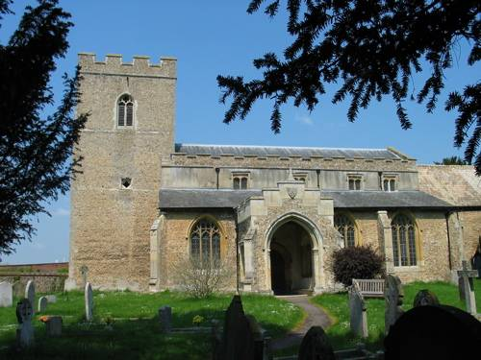
If your exercise regime requires 10,000 steps, check it about here. Though you may have taken 2 or more leisurely hours you’ve walked nearly 5 miles and a pleasant lunch awaits.
Reaching a small wood, ahead you can see farm buildings and the dome of Babraham Hall.
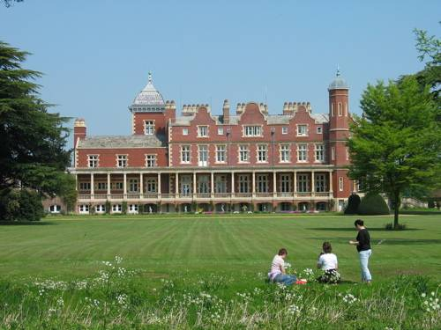
Skirt round the industrial buildings and you will find the stream and a weir on your left and catch a glimpse of the attractive church. Cross a bridge into the churchyard – though if lunch beckons, you can stop on the way back. Unfortunately the church is usually locked, though a key is available at Stanley House.
Beautiful gardens to the west of the churchyard are accessible from Babraham Hall.
Moments after passing the bridge to the Church look left to see a magnificent view of Babraham Hall.
Take the little path which goes alongside Babraham pocket park and cross the river for the third time (or if you have a picnic you could stay on the bench in the pocket park.)
Turn left up the High Street, noting the public footpath to Abington (1¹/₂ miles) to the right which has potential for further walks. A little further up the road is The George (TL513503) but don’t miss the noble monument to Jonas Webb who “had farmers and friends in many lands”.
The George [ http://www.georgeinnbabraham.co.uk/ phone 01223 833800] is an old coaching inn, reworked as a gastro pub and serves food from 12 to 2.15. After some 6 miles you deserve drink at least.

Our way home is shorter and simpler.
Retrace your steps from The George to the pocket park but (unless you are revisiting the Church) continue along the High Street, over the road bridge and past the school to the track on the right called Rowley Lane. Long and straight, it runs roughly parallel to the riverside path we followed to the Church. Don’t miss the now distant vista of Babraham Hall.
From the right come several paths which lead back to the church or up to Wandlebury.
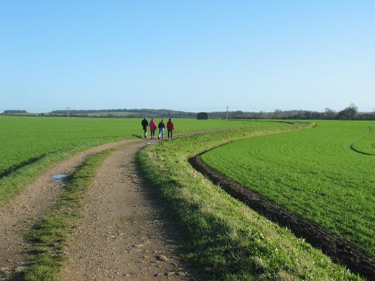
At the river (The Granta again – 5th crossing!) take the left track past the black barn to Bury Farm and you are again in Stapleford, only an hour after leaving Babraham.
Proceed straight ahead to the Sawston Bridge and bear right at the Rose. Next right and you pass The Longbow, then the road curves round into Mingle Lane, past the church. At the end of the road turn left at Hinton Way and Shelford station is 100 yards away.

