Shelford Feast outline site plan. 2016.

The Feast is based on the recreation ground in Woollards Lane, Great Shelford. During the week-long Feast the site is protected by Heras fencing separating the site from the public car park and remaining areas of the public recreation ground. Access is permitted by the public from the car park from approximately 7pm to 11pm and by authorised personnel from a rear entrance to the south east of the site. Activities take place in a long marquee placed east-west across the north of the recreation ground.
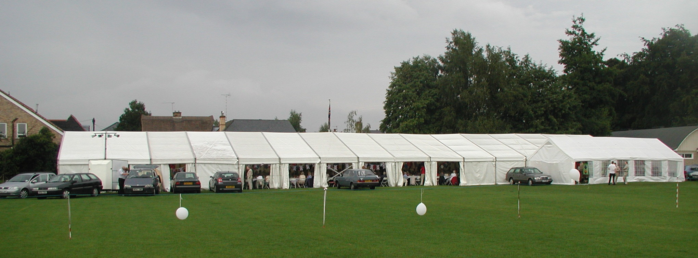
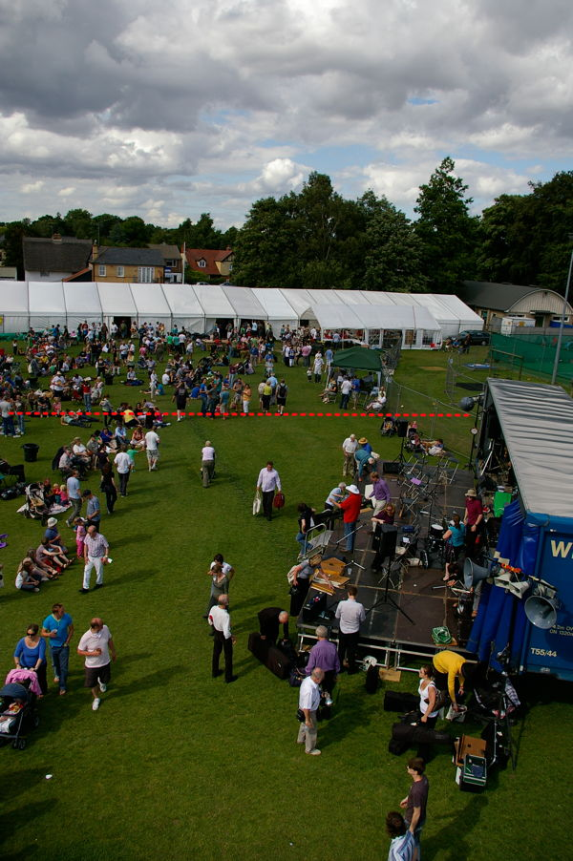
Aerial view of marquee on Feast Day. For most of the week Heras fencing (marked in red) separates the marquee from the rest of the recreation ground.
In plan below Heras fencing marked in dashed lines, marquee in bold lines. Note the car park on Woollards Lane and that there is a separate entrance to bottom right of the plan.

